# Introduction

The purpose of this document is to validate whether the CampusNexus Engage application is setup and running correctly on a Dynamics Organization. The target audience for this document is the Implementation/Deployment team.

# Sanity Test for Engage Application (Mandatory)

* **General**
* **Entity**
* **Dashboard**
* **Data Import**
* **Portal**
* **Azure Functions**

## General

Login to CampusNexus Engage Application and navigate to Engage > Dashboard > Admissions Lifecycle Overview

The following page must be displayed.

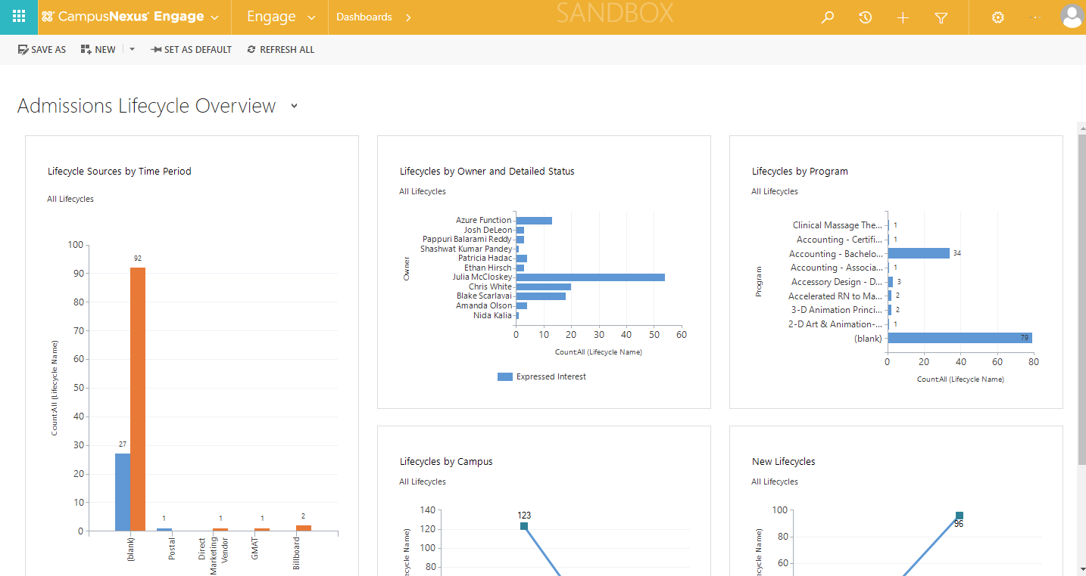

## Entity

Check if Views, New, Edit (Open only) Forms of the below entities load fine

* **Account**

Navigate to Engage > Constituents > Account

Views:

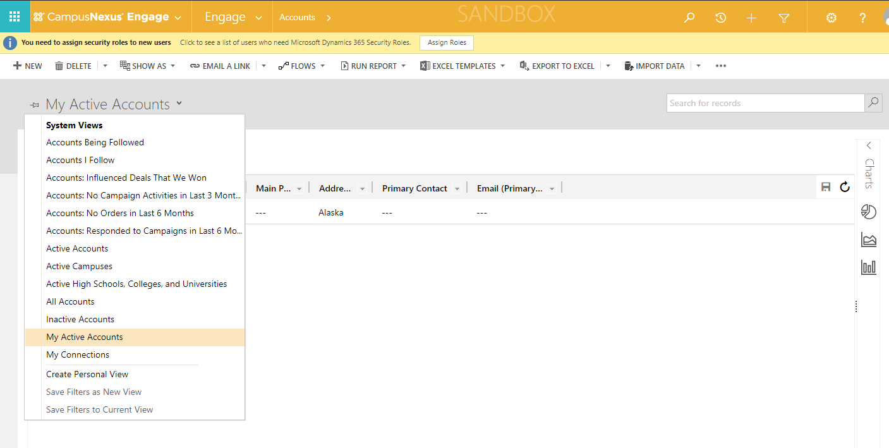

New:

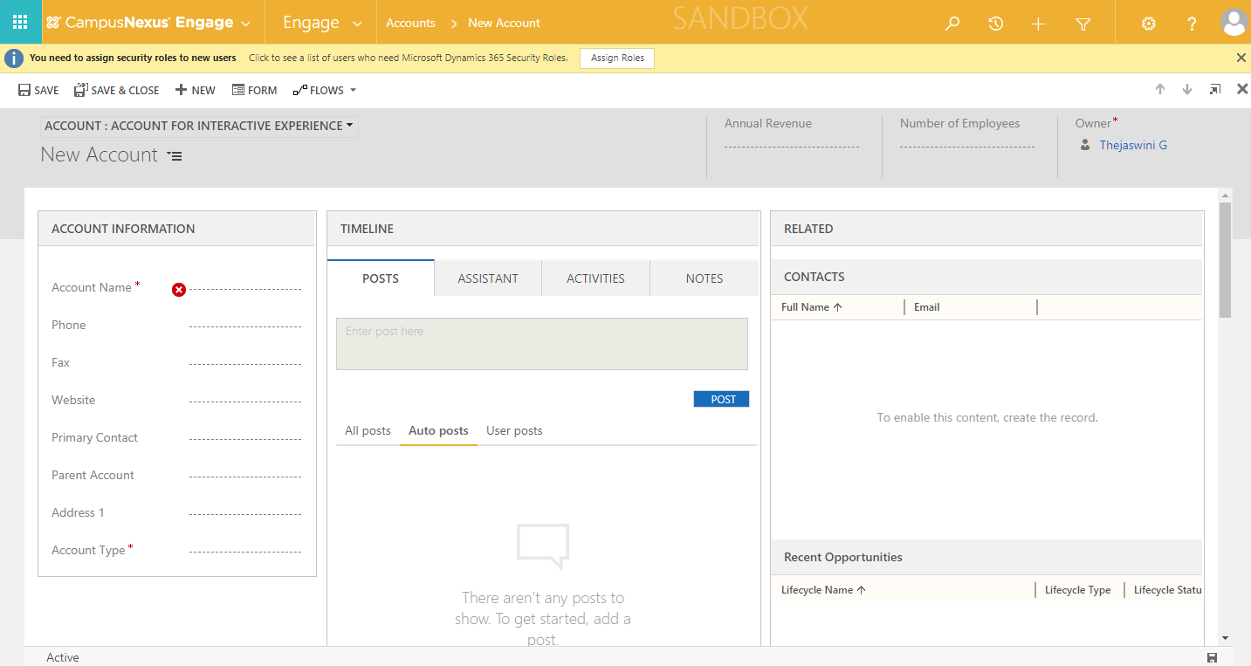

Edit:

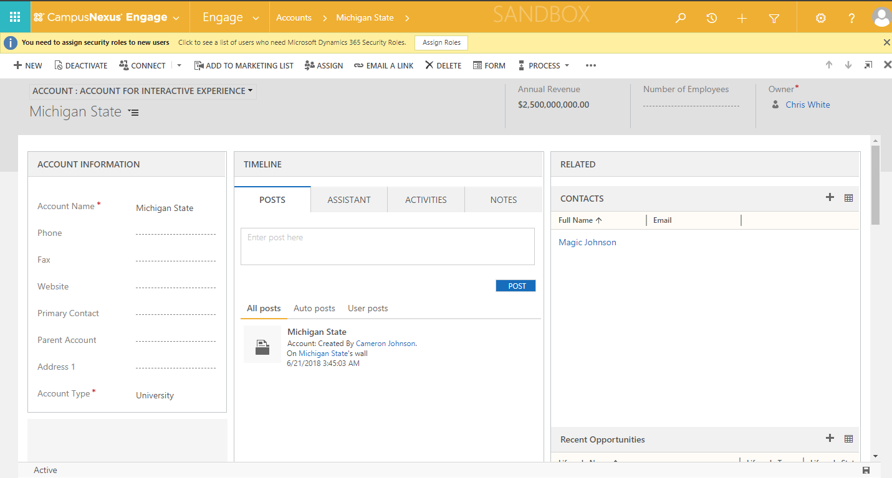

* **Contact** (Timeline, Internal Connections, Retention Score Gauge)

Navigate to Engage > Constituents > Contact

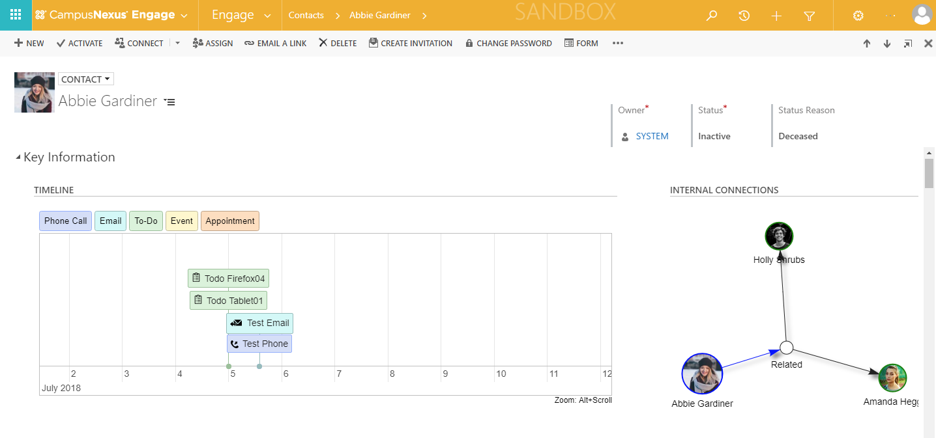

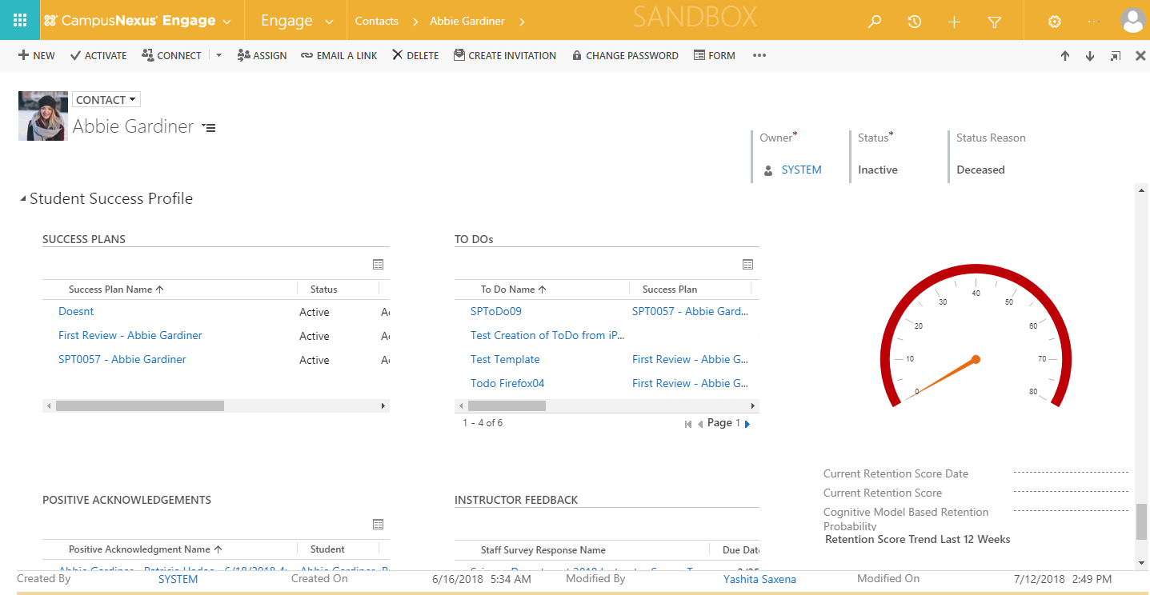

* **Inbound Interest**

Navigate to Engage > Recruitment > Inbound Interests

* **Lifecycle**

Navigate to Engage > Recruitment > Lifecycles

* **Trip** (Bing Maps)

Navigate to Engage > Recruitment > Trips

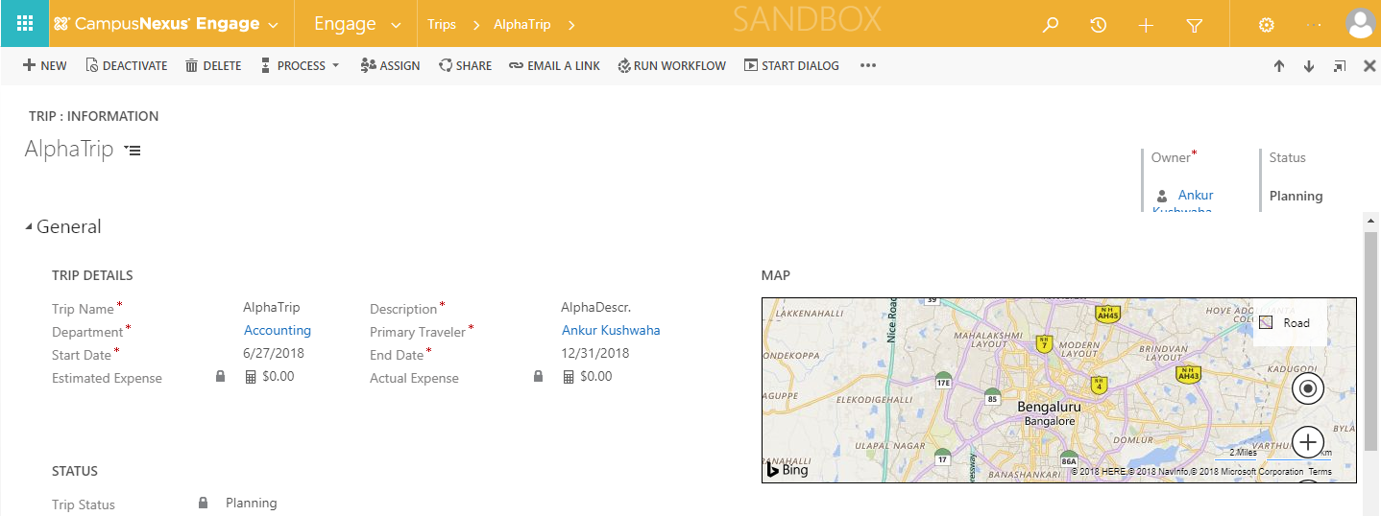

* **Success Plan**

Navigate to Engage > Student Success > Success Plans

* **Staff Survey** **Template** (Survey Template Designer)

Navigate to Surveys > Staff Survey > Staff Survey Templates > New > Designer

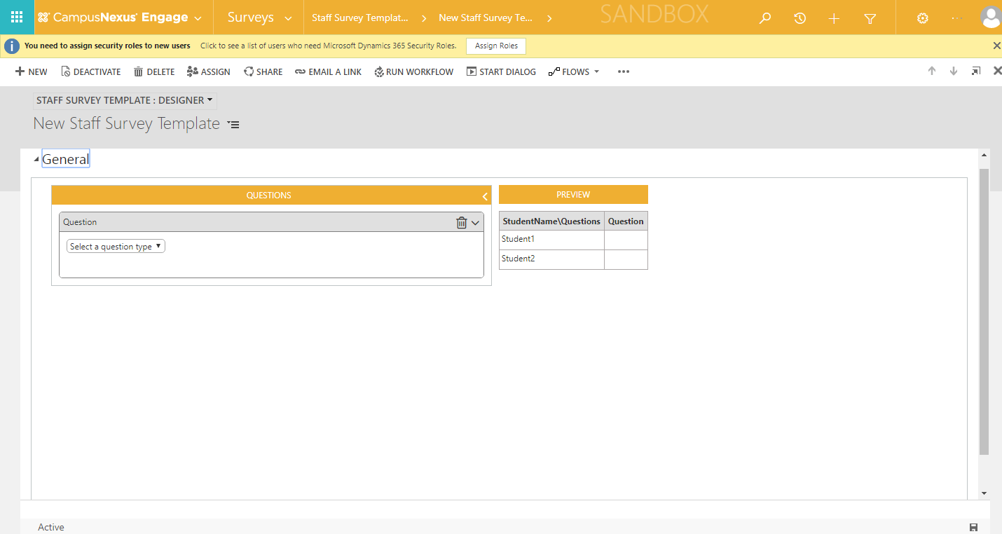

* **DOM** (Attribute filter assignment)

Navigate to Process Config > DOM > DOM Definition Logic

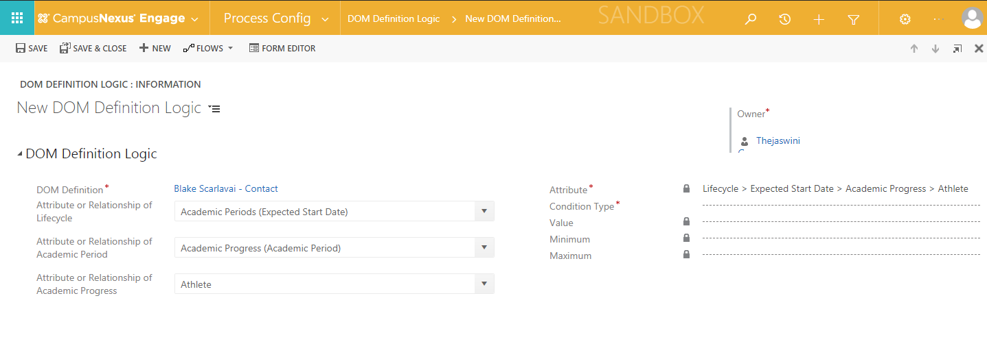

## Dashboard

Navigate to Engage > Dashboards > Retention

The following page must be loaded correctly.

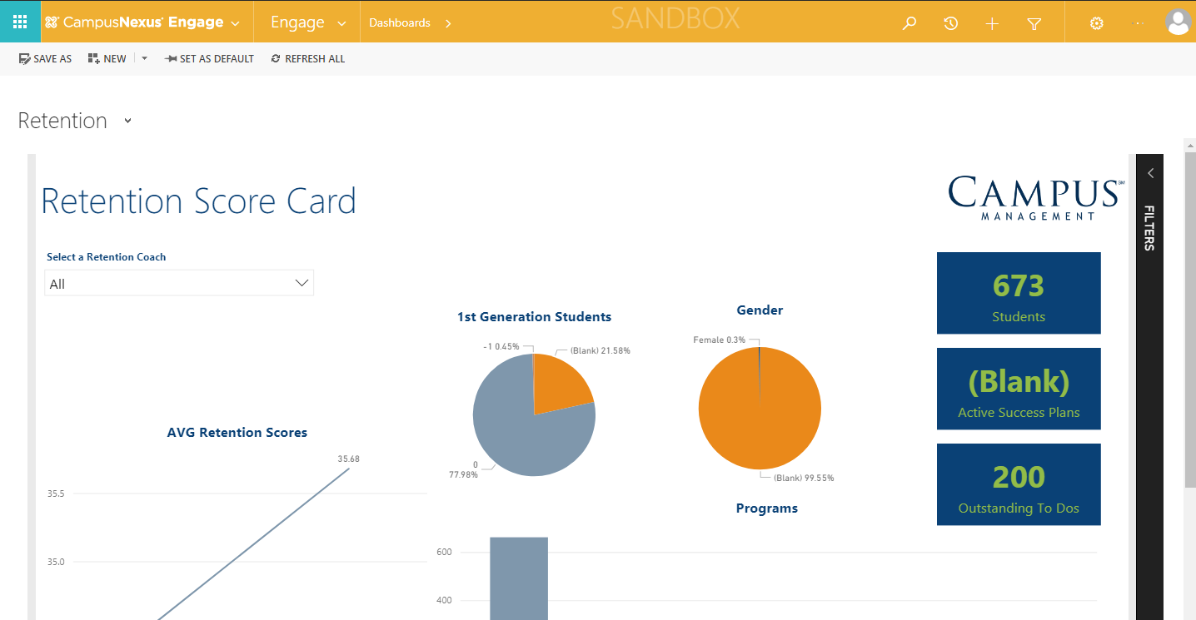

## Data Import

**Verify Reference Data**

Navigate to Reference Data >Area of Interests

The following page with the data must be displayed.

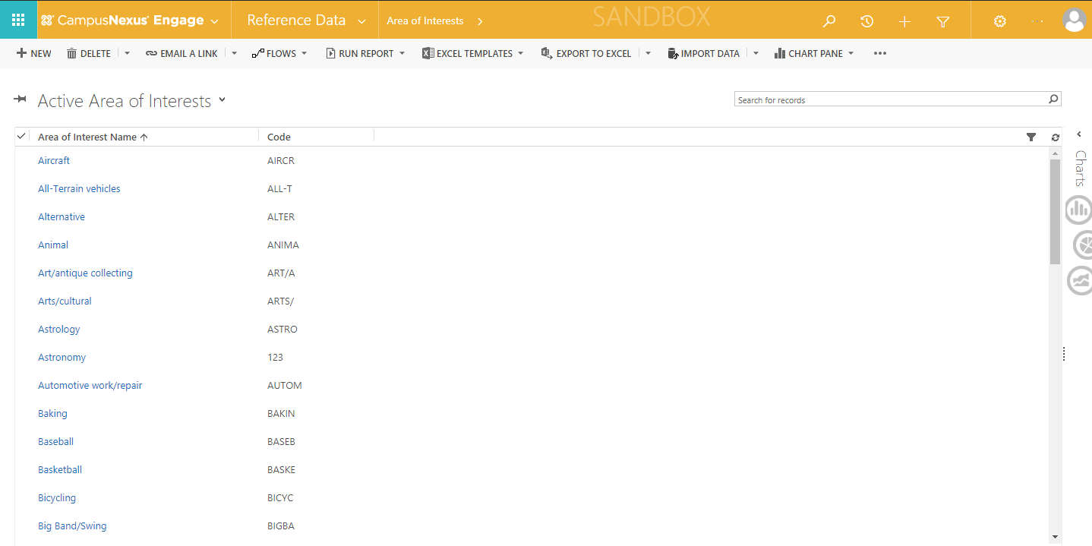

**Verify Filtered Data**

* Navigate to Settings > Security >Teams

Check Student Portal Cases record exists

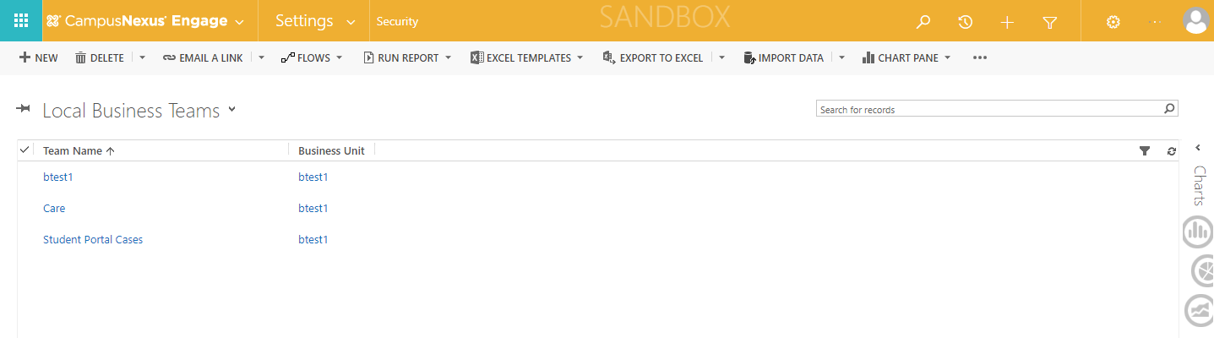

Open Student Portal Cases form and verify the ‘Default Queue’ field is set to ‘<Student Portal Cases>’

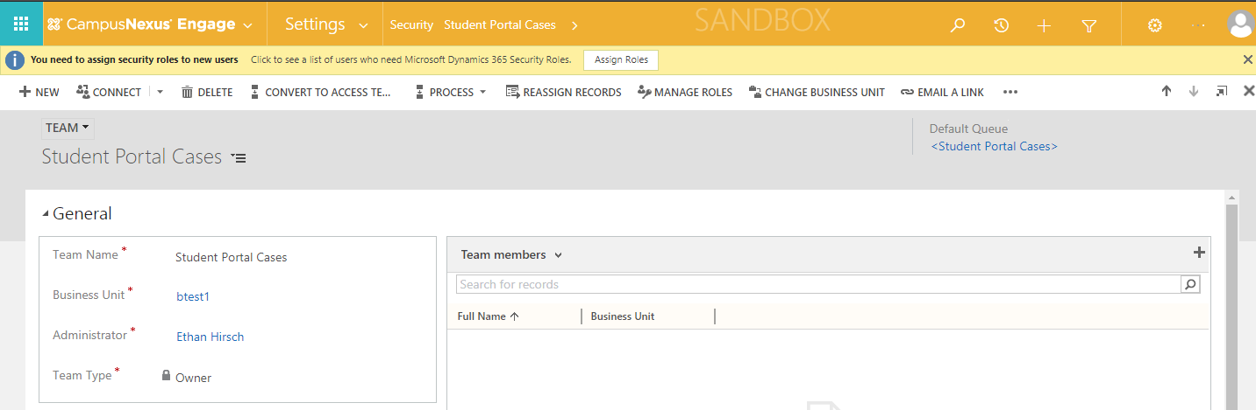

* Navigate to Settings > Data Management > Data Detection Rules

Check all the Duplicate Detection Rules are Published

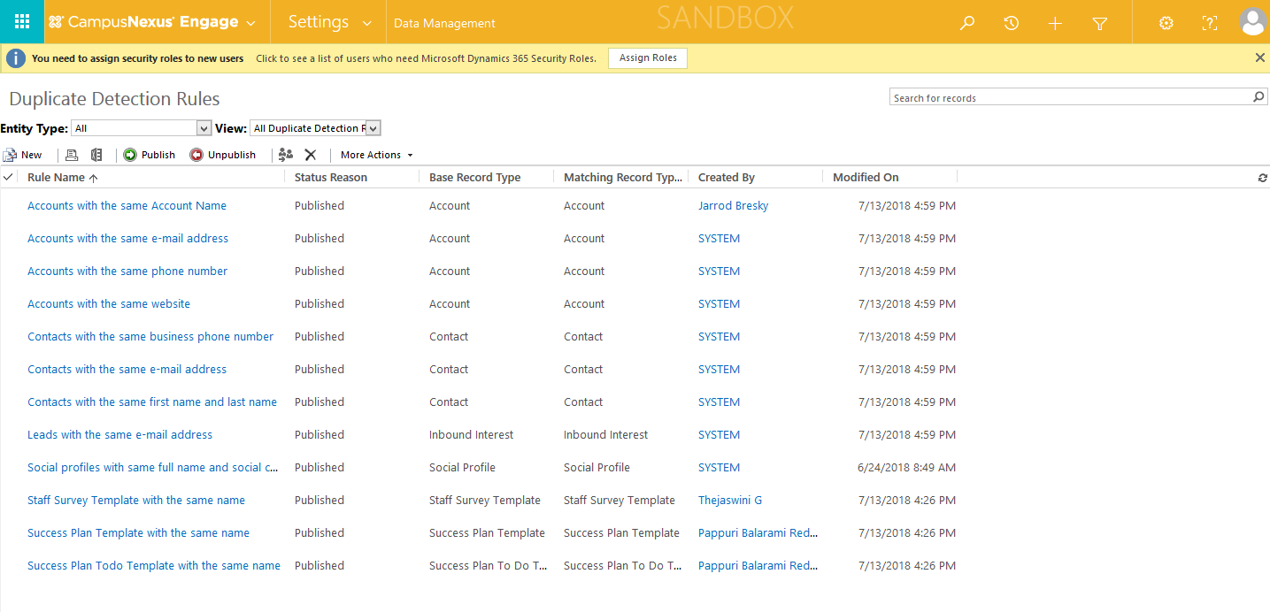

* Navigate to Settings > Customizations > Themes

Check CampusNexus Engage Theme is available and should be set as Default Theme.

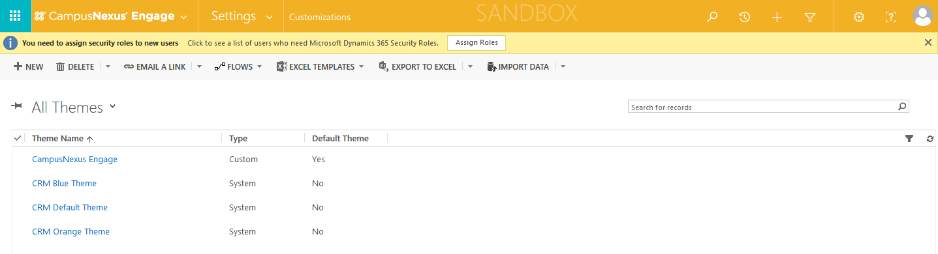

**Verify Survey**

Navigate to Settings > Solutions > Campus Management Extended

Check the Voice of the Customer Dashboards exists

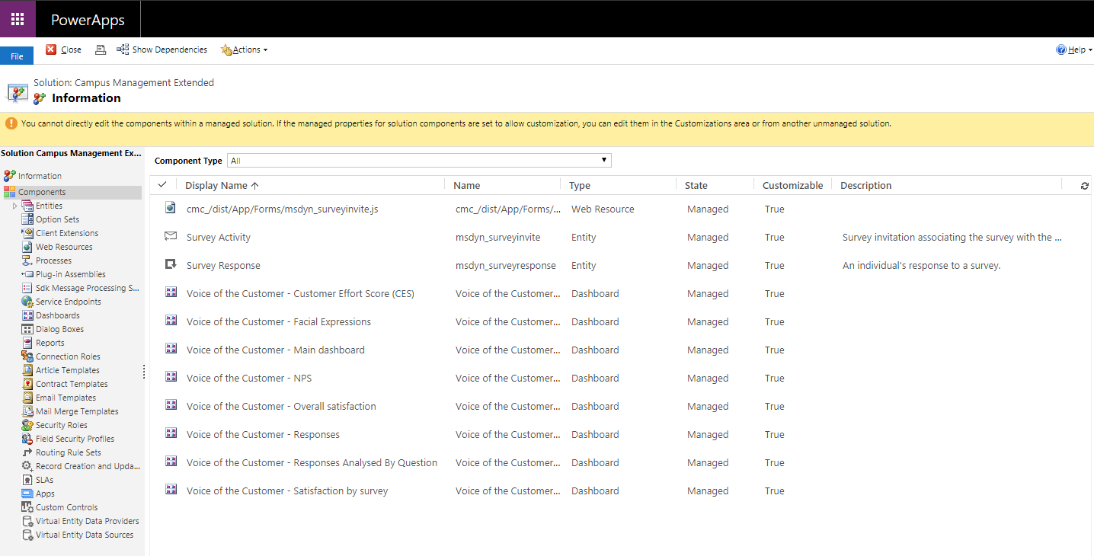

## Portal

Login to Student Portal > Navigate to Appointments

The following page must be displayed.

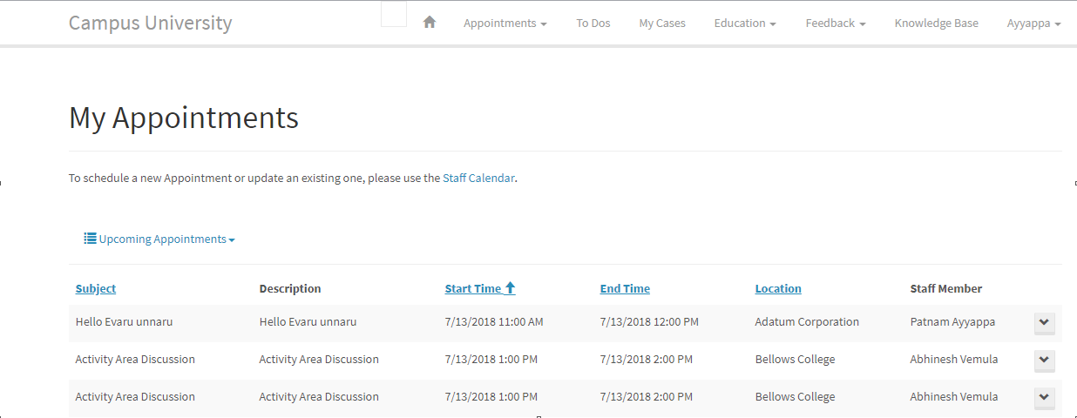

## Azure Functions

Login to <https://portal.azure.com>

Navigate to Function Apps > Expand the Function App >Run AddressGeoCoder Function => Function should run successfully

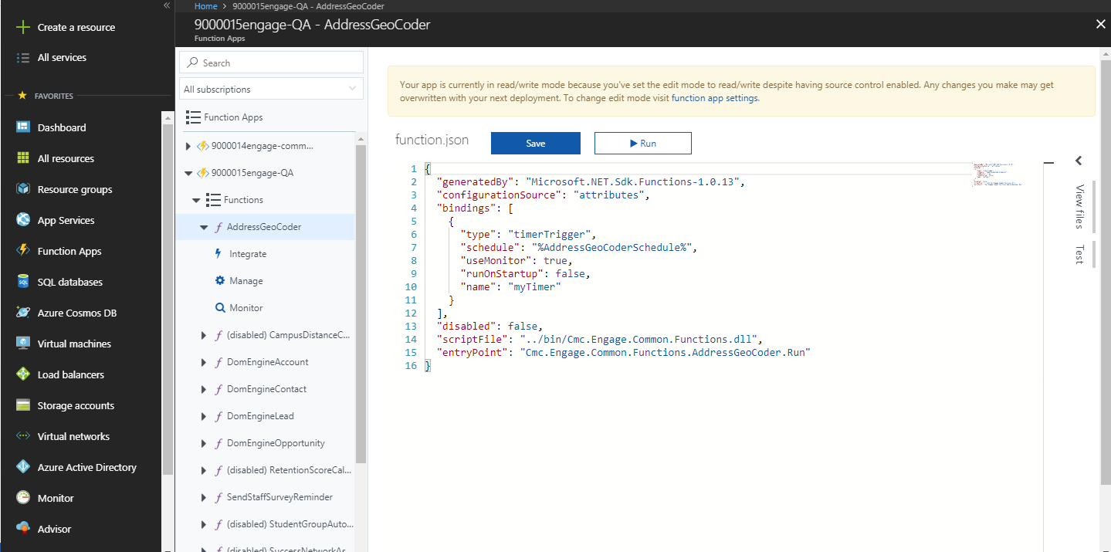

Navigate to Function App > Application Insights > Search > Click on ‘Click Here’ link > Check the Traces under the Results tab =>Traces related to AddressGeoCoder function should display

